**Arrays – Question-1 Google Interview Question Two Sum (Easy)**

* **Interview Question -1 Two Sum:**

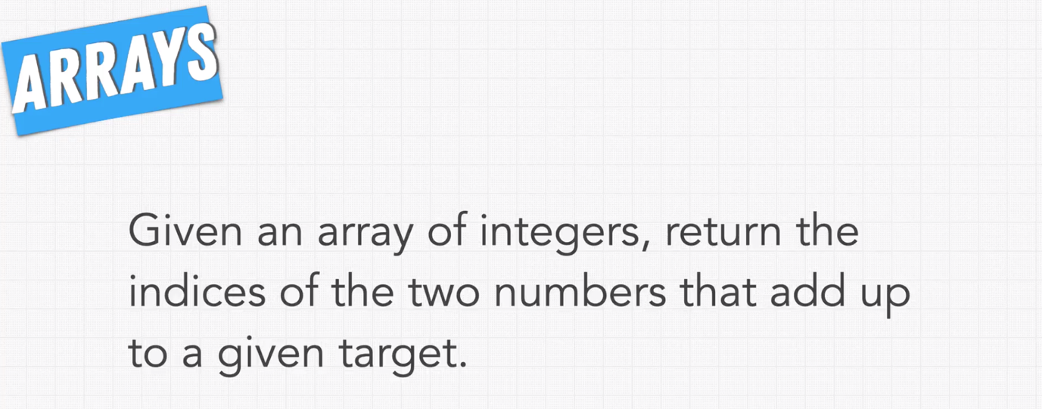

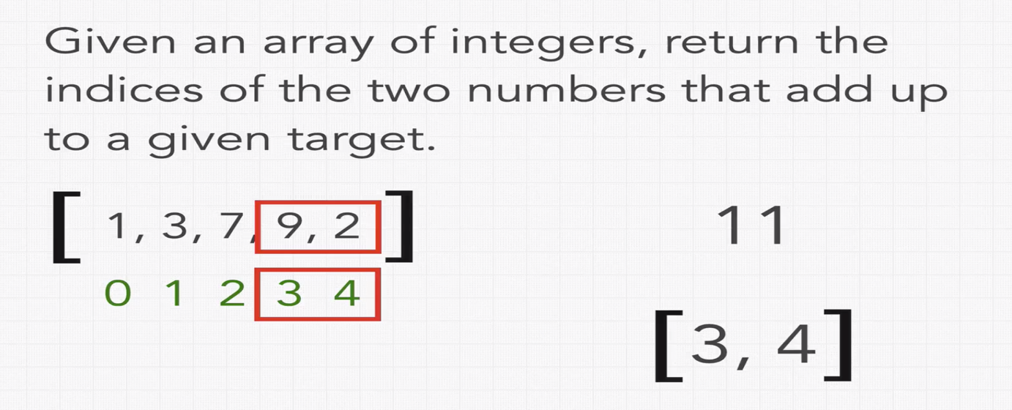

**In interviews, once you understand the problem, you shouldn’t start writing the logic, we have to ask list of constraints. Following are the constraints we can ask for above problem.**



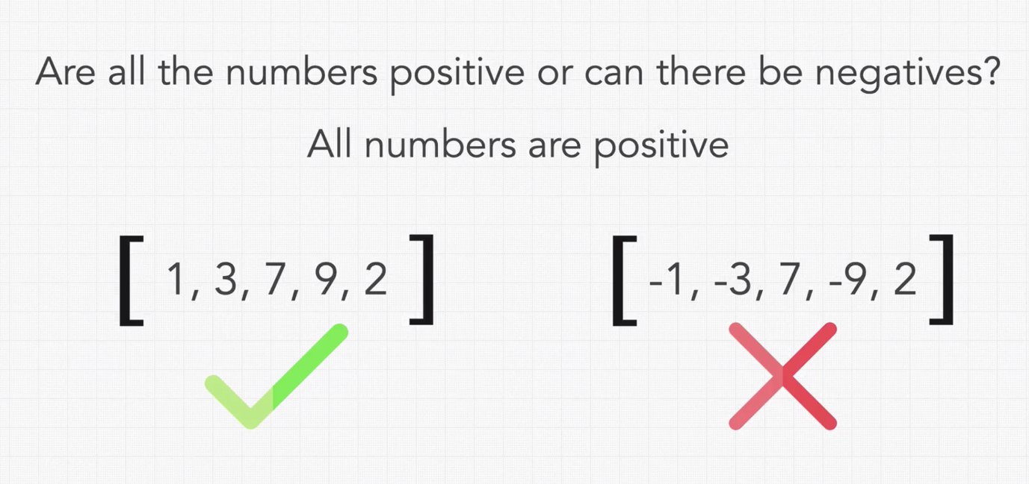

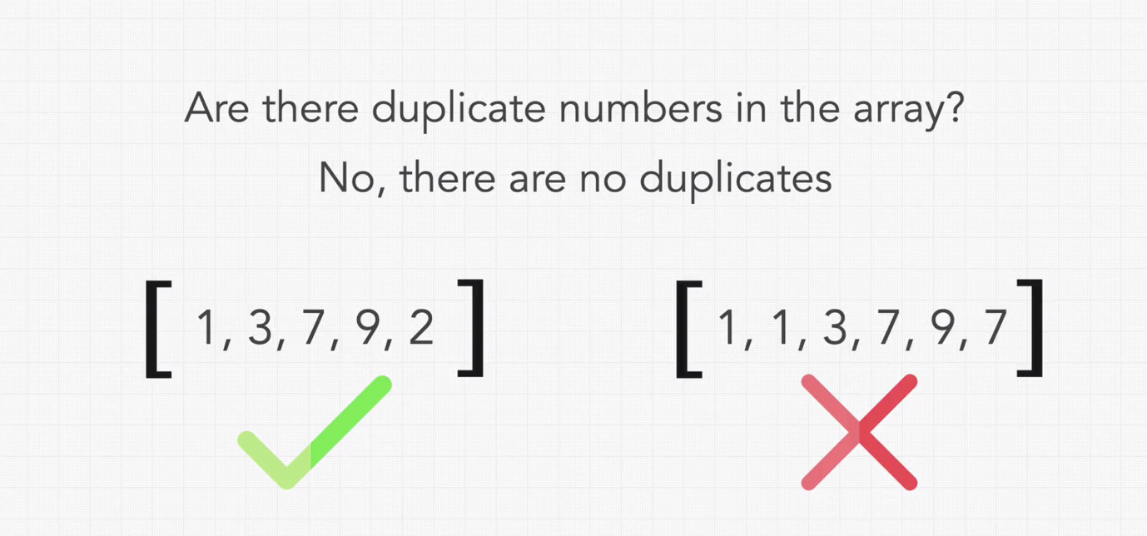

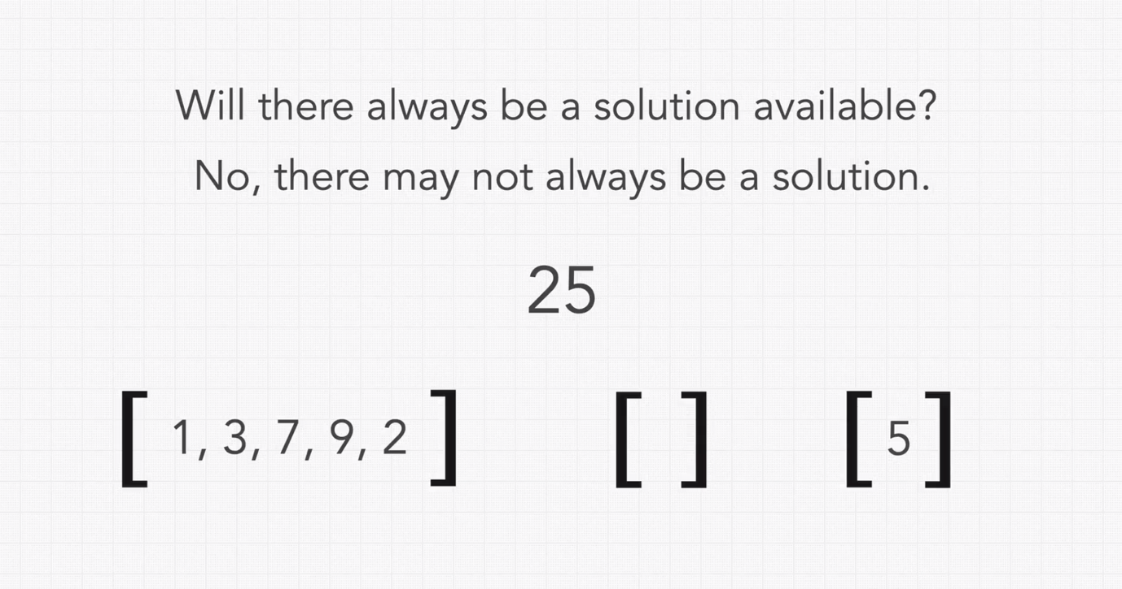

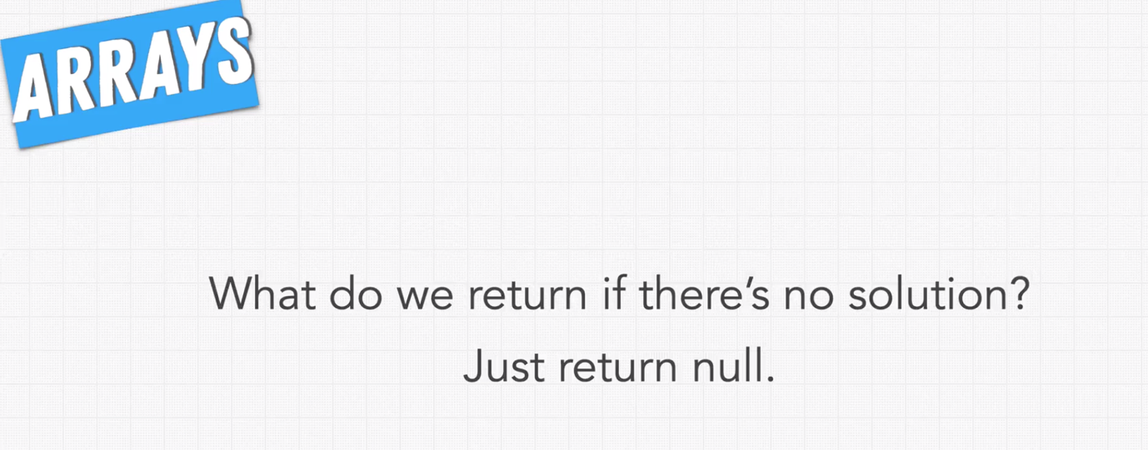

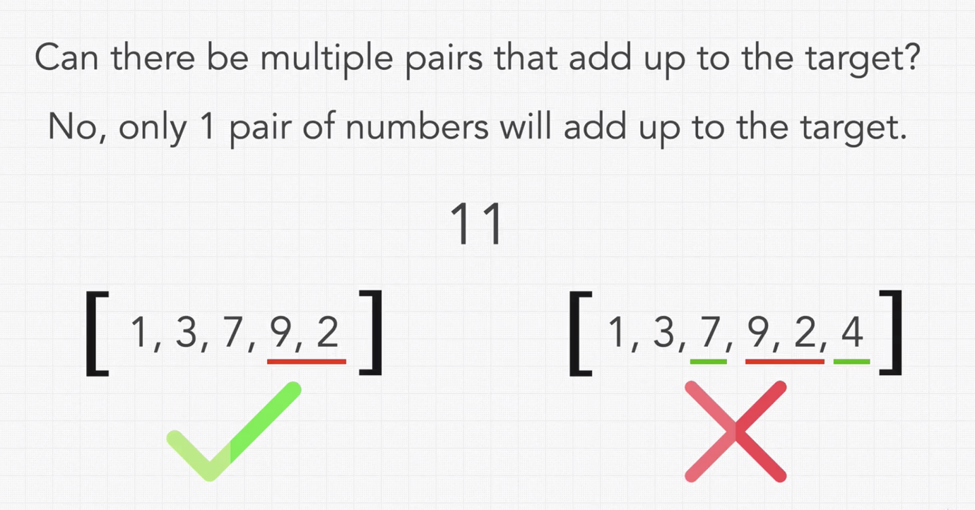

* **How to Approach Our Problem:**

Once we asked and got the answer for all constraints, step-2 would be writing test cases.

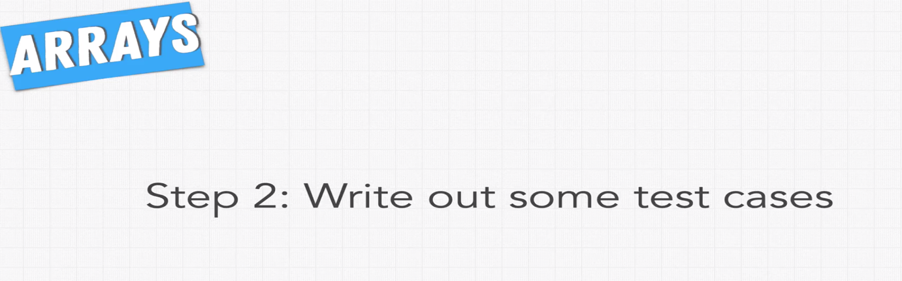

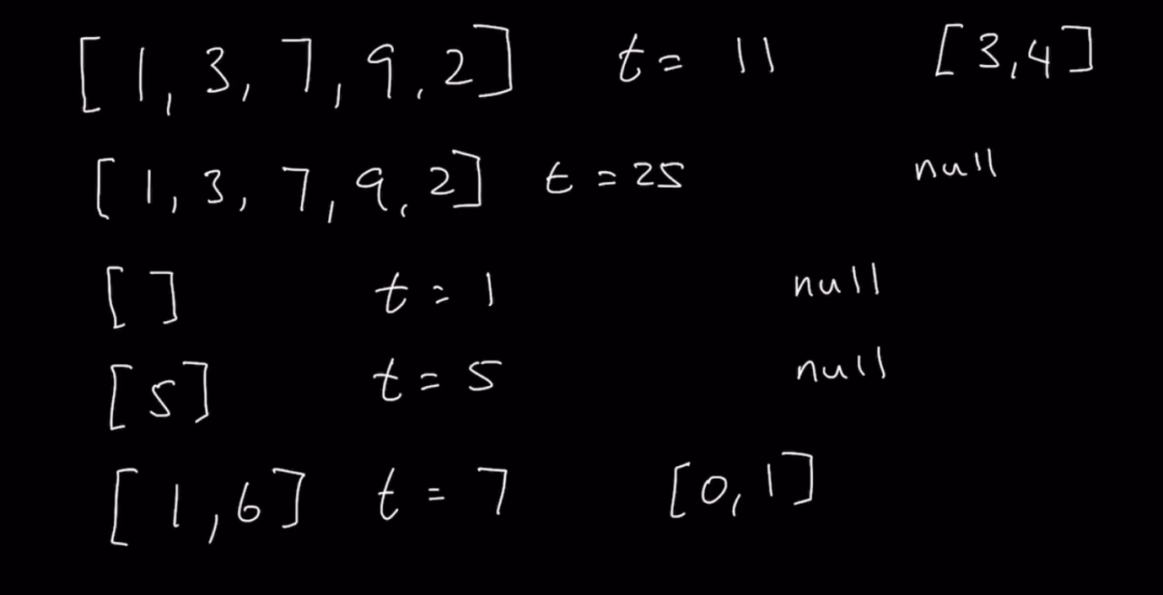

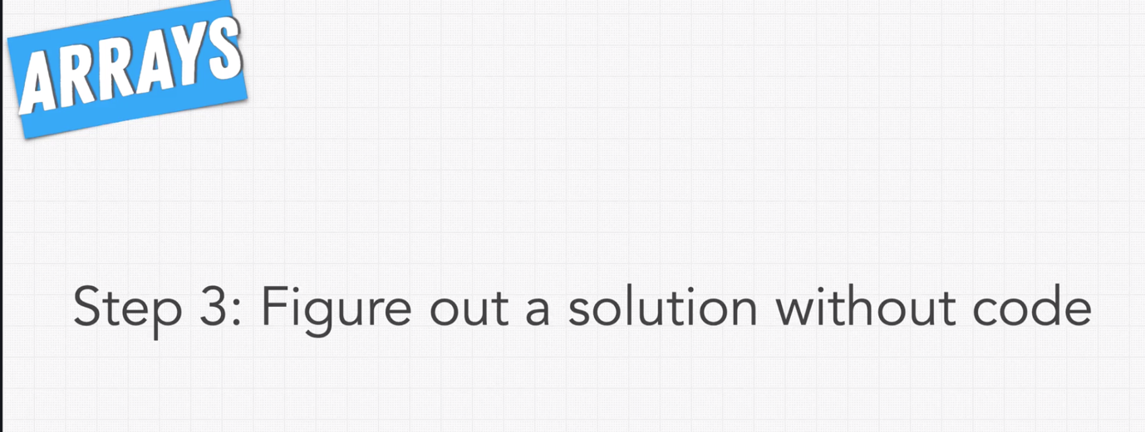

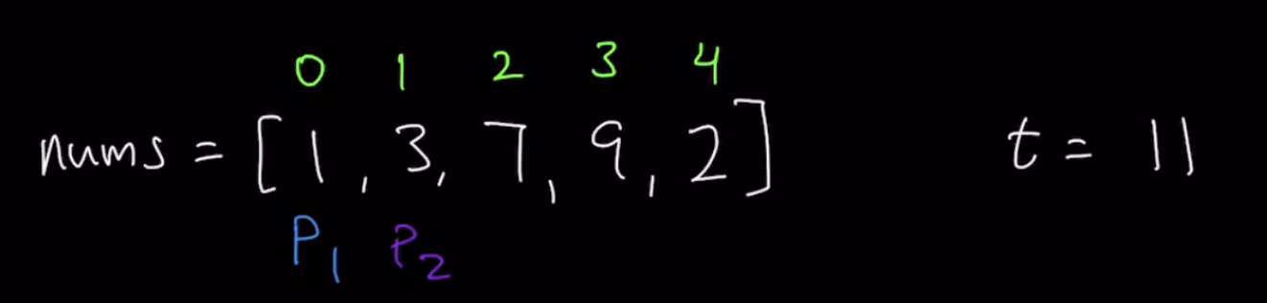

This approach is called – two pointer.



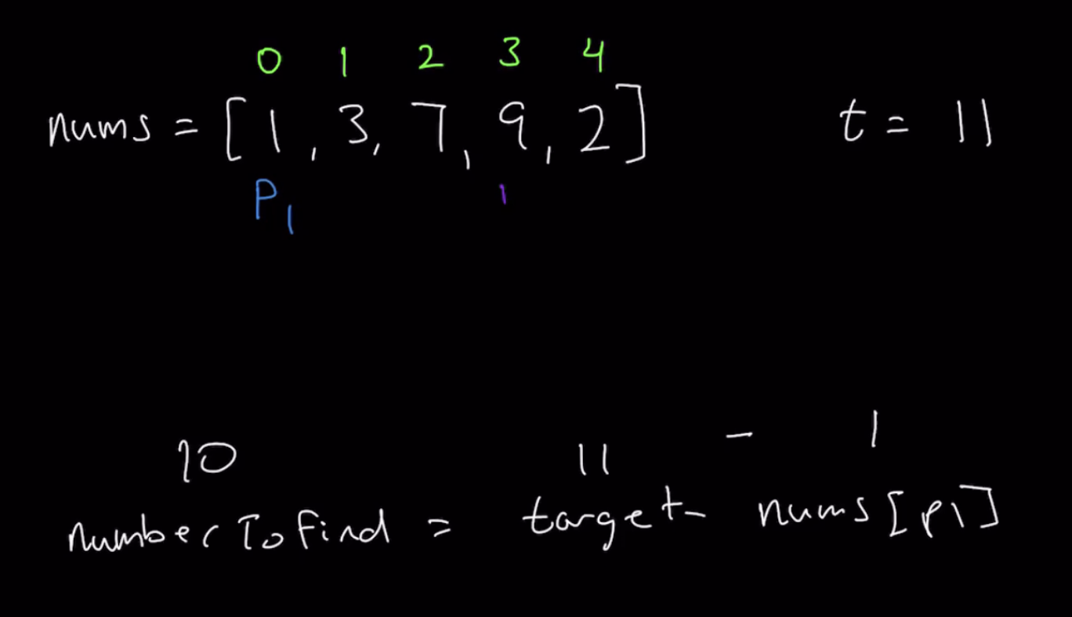

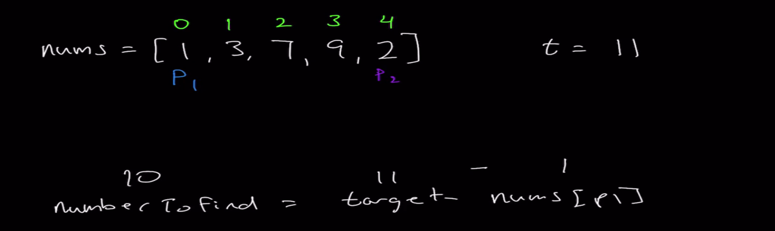

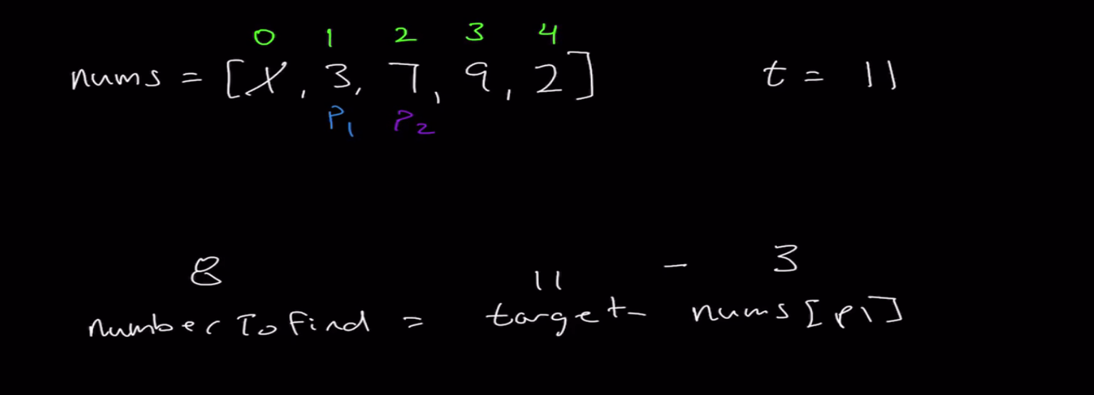

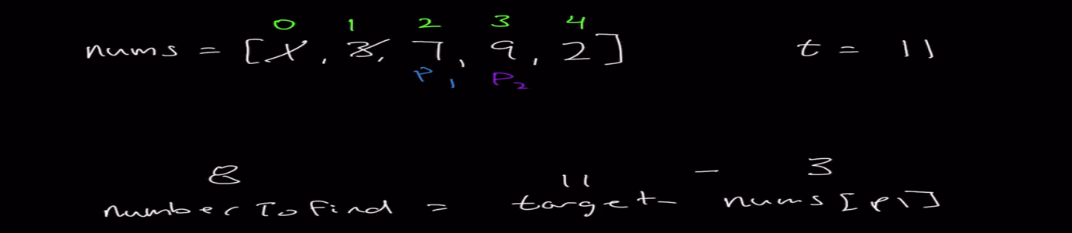

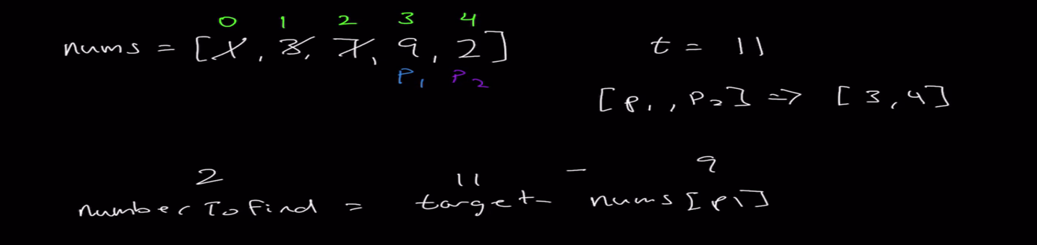

* **Writing Our Brute Force Solution:**

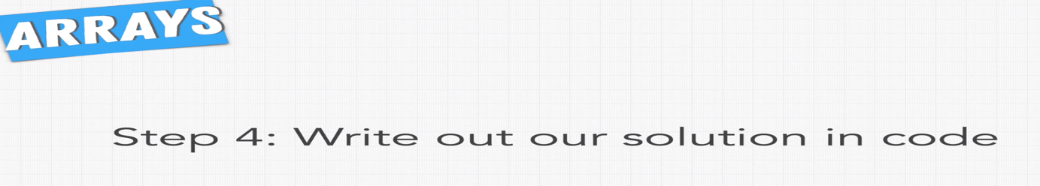

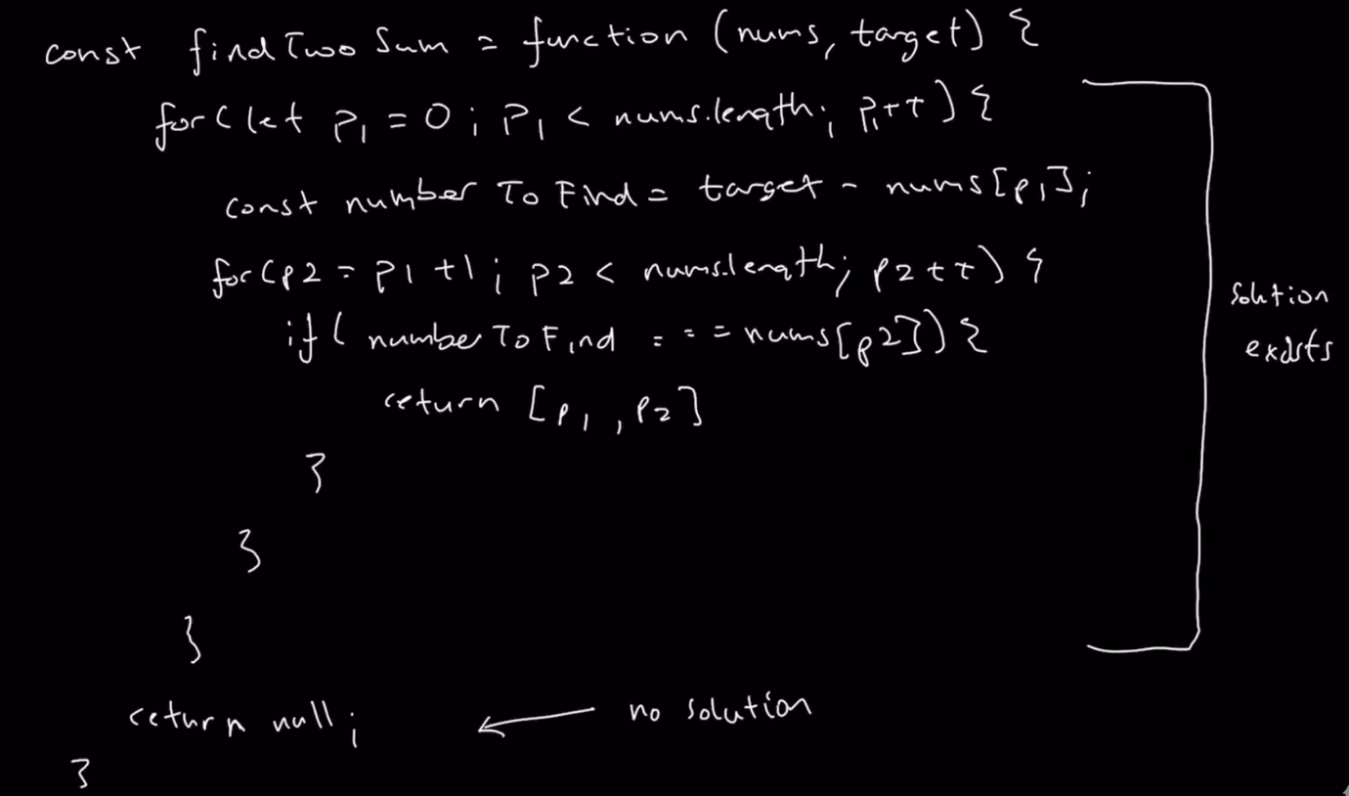



Double check the code we written for syntax error, method name etc.

Note: Always do the coding without IDE, so that you will get to know all the method names, keywords etc. We have to write the code on Notepad like apps in such a way that, if we copy and paste the code on IDE, it shouldn’t throw any error(s).

* **Testing Our Optimal Solution With Our Test Cases:**

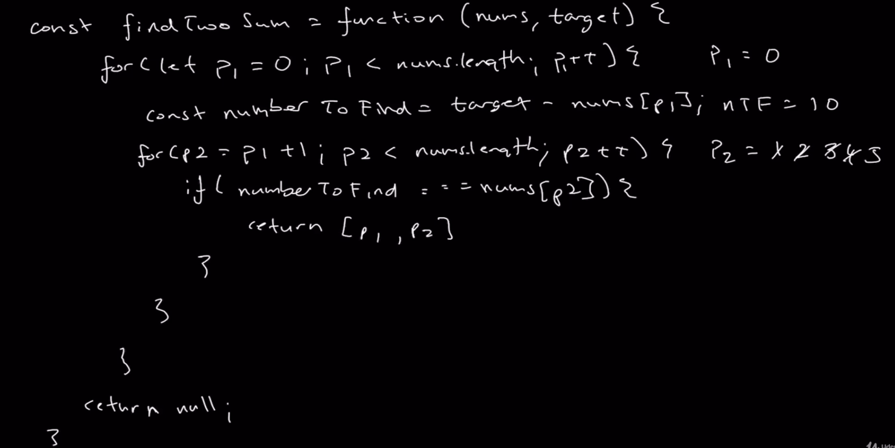

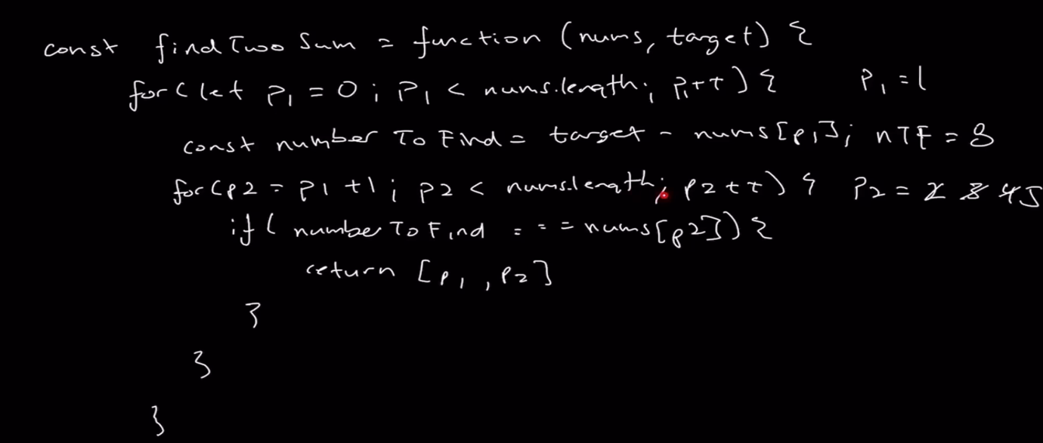

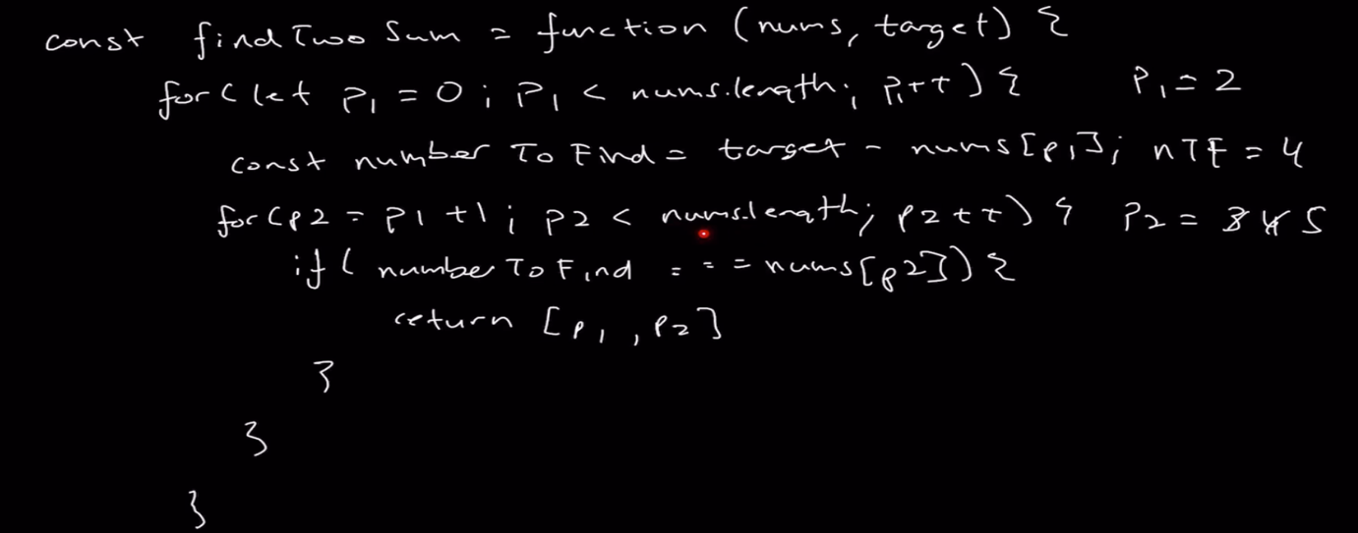

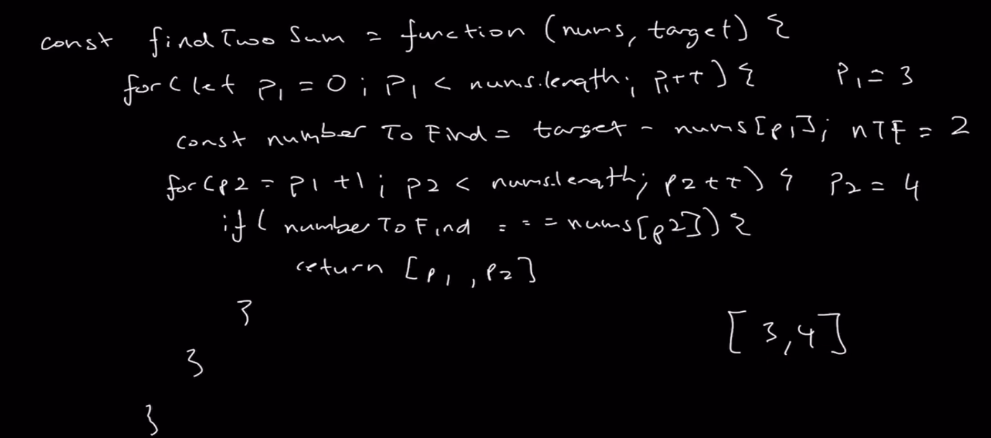

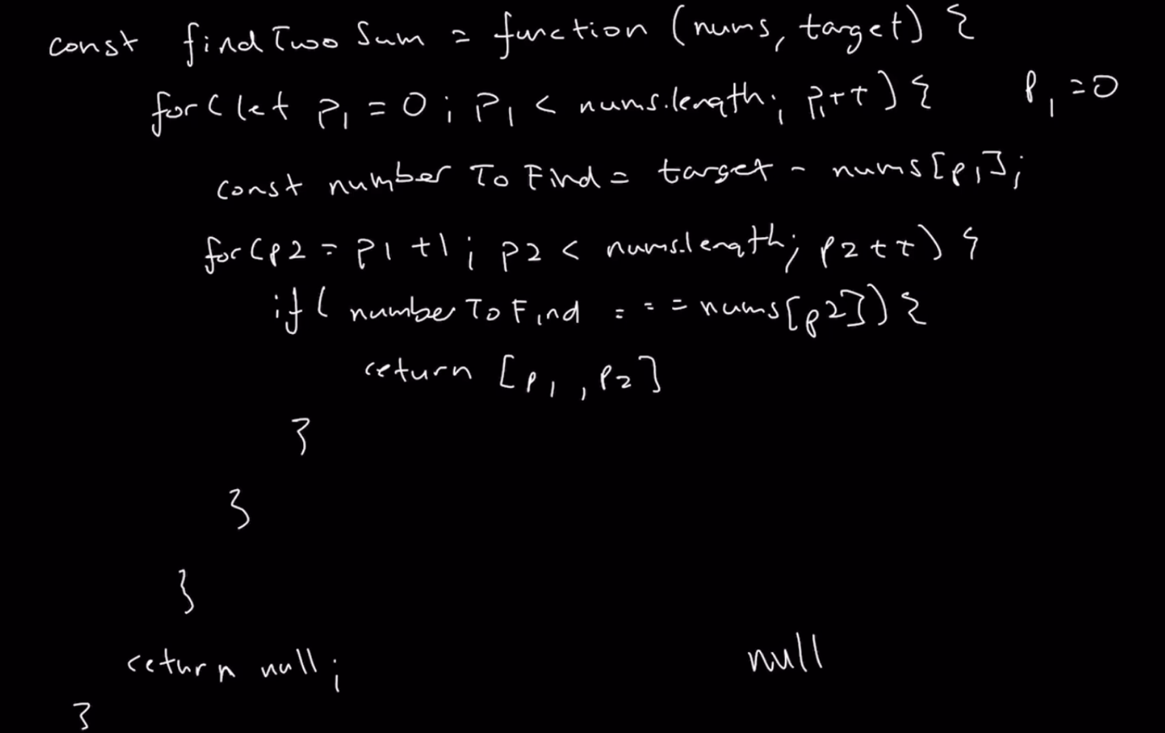

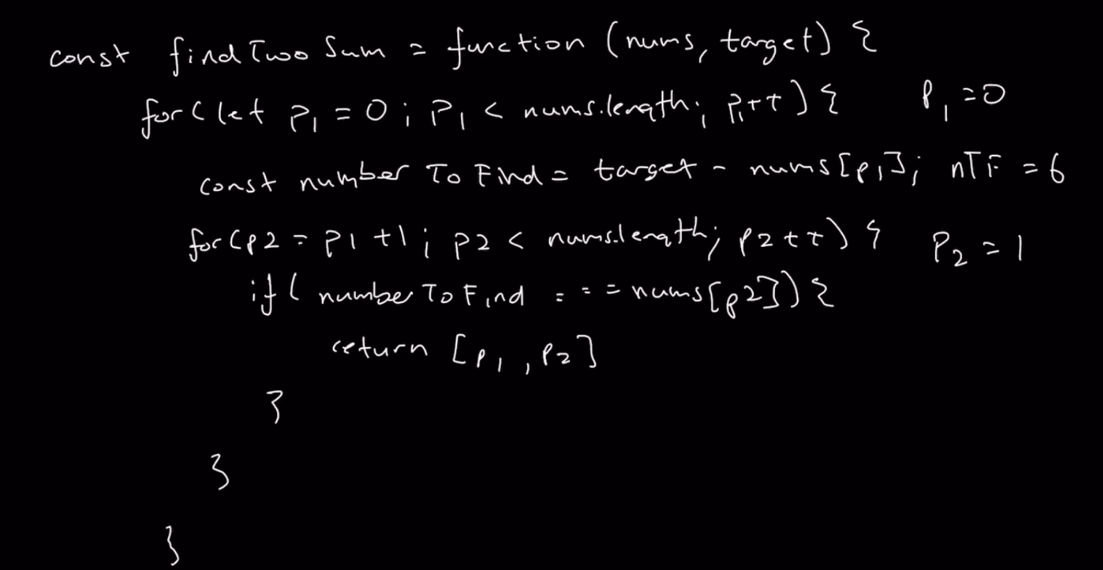

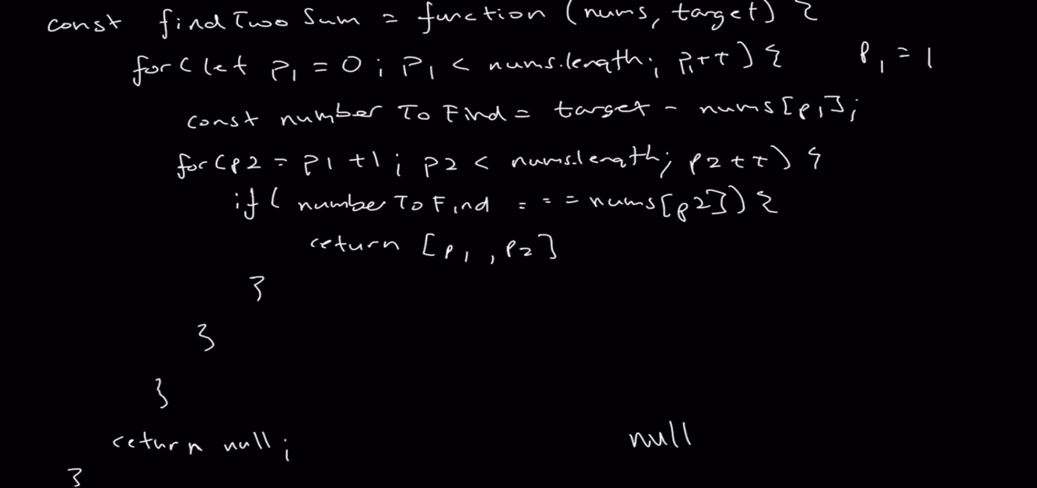

* **Submitting to Leet Code:**

Visit this URL for more information, this is same like repl.

https://leetcode.com/

* **Analyzing Space and Time Complexity:**